Statistics Lecture 4.7: Fundamental Counting Rule, Permutations and Combinations

Coin and Die:
How many outcomes can you get when you flip a coin? Answer 2
How many outcomes can you get when you roll a die? Answer 6

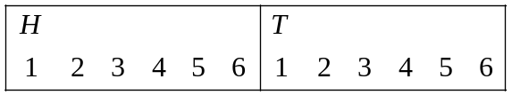=12 outcomes

Fundamental Counting Rule
If you have an event that can occur “m” ways and another event that can occur “n” ways, then
together they can occur ways.

Security code:
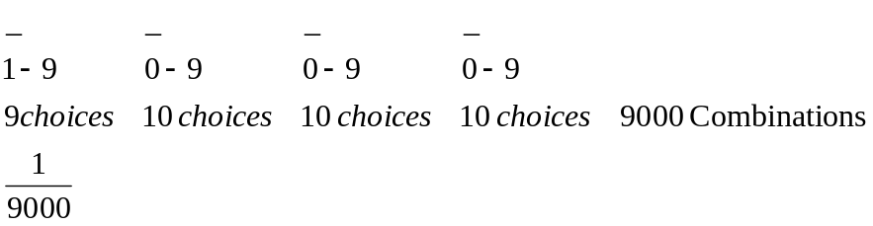

First digit cannot be zero

Security code:
First digit cannot be zero or one
Last digit cannot be zero
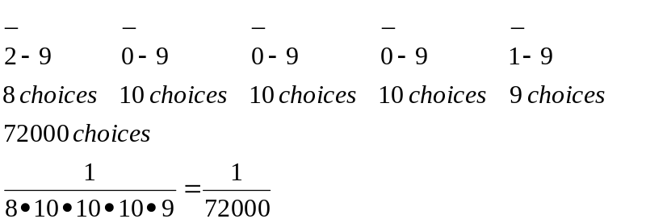

First digit cannot be zero

Example
1 Apple, 1 Orange, 1 Banana, 1 Grape, 1 Kiwi
How many arrangements of fruit can you have? Once you place a fruit into a slot that fruit is gone.
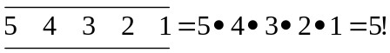= 5 factorial= 120 different arrangements of 5 unique items.
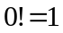 zero factorial always equals 1

* for any n different items can be arranged in n! ways

Example
There are 7 cool rides at Disneyland, how many different ways could you ride on all 7?
7!=5040 ways

Permutation:
A different arrangement of items
n unique items 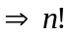 arrangements
But, sometimes you just need a few.

Rules for Permutations
- n different items (Items must be unique)
- r the number of to be arranged out of n
- Arrangement/order matters.

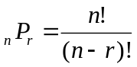

Example
There are 58 counties in California, you need to visit 4 of them.
How many ways can you do that?

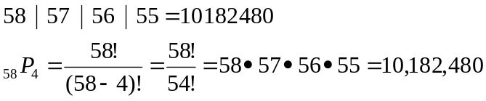

Permutation:

Example
There are 10 people want to be who want to be president, vice president, treasurer and general.
We need to select 4 people to lead the country. How many arrangements of people to lead the country I is there?
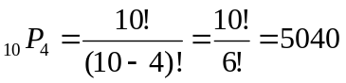

Example
3 apples, 2 oranges, 5 bananas.

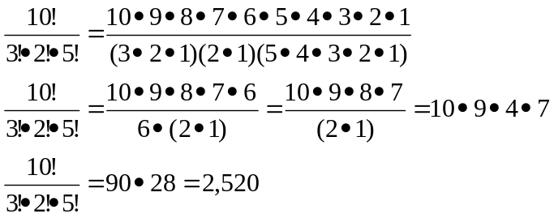

For non-distinct items
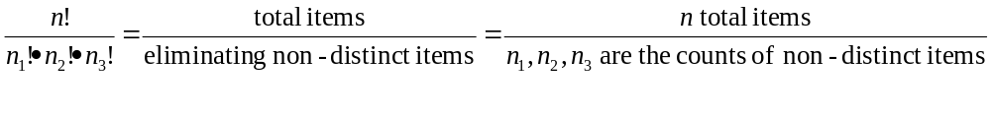

Example
How many different ways could you arrange this letters?
Statistics.
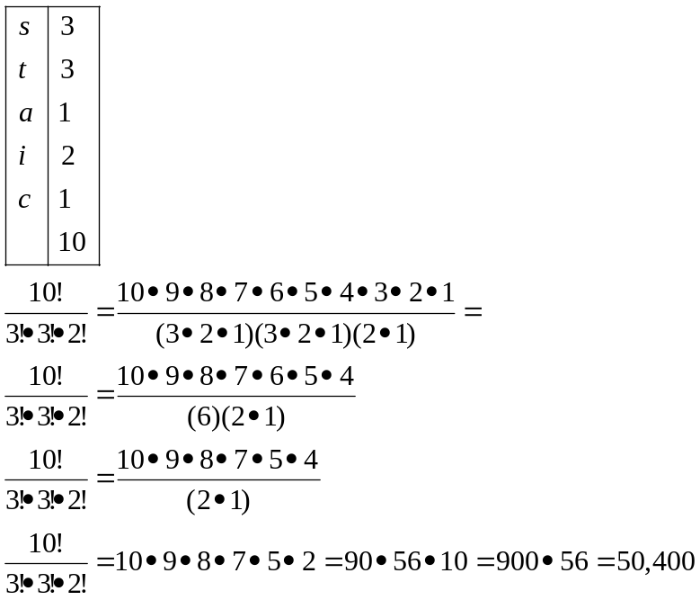

Example
How many ways could you plan to have a family with 7 girls and 5 boys?
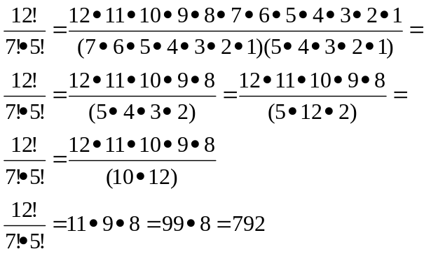

Sometimes order does not matter.

Go on 5 rides out of 25 rides at magic mountains. Do not care about which order you go on the rides.
How many combinations of the 5 rides could we select?
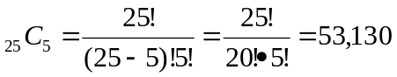

Combination Rules:
- n distinct items.
- Select r items.
- Order does not matter. ABC is the same as BAC.

